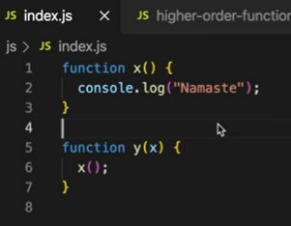X()->callback fun()., Y()-> higher order fun().

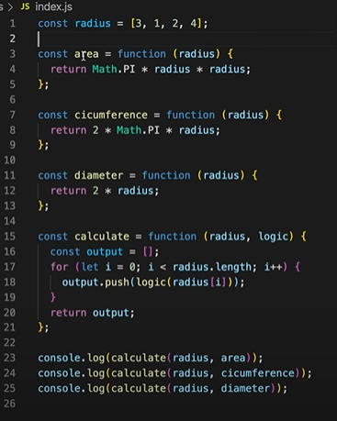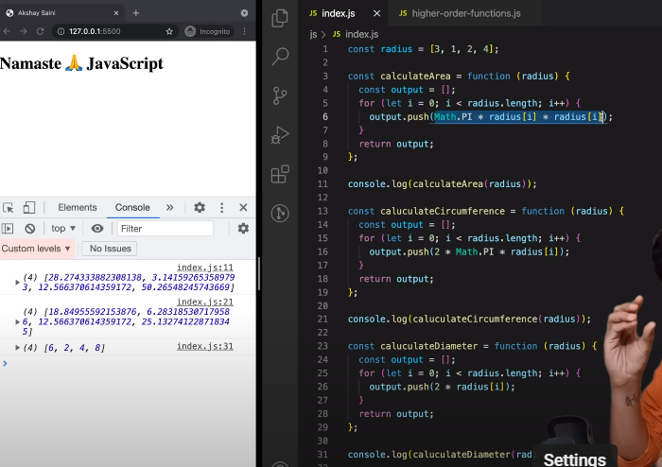



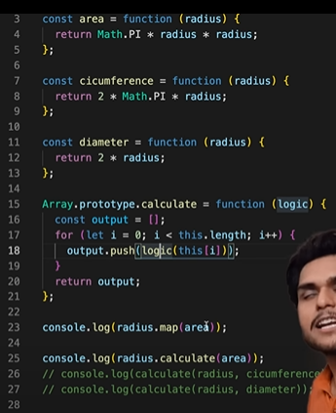

Things learned:

1. Follow DRY(Don't Repeat Yourself) principle while coding.

2. Use function to stop writing repeating line of codes.

3. Function that takes another function as argument(callback function) is known as Higher order functions.

4. It is this ability that function can be stored, passed and returned, they are called first class citizens.

5. If we use Array.property.function-name. This function is accessible to any array in your code.